Effects on Mental Health of Health Care Workers Due to CovID-19

Qazi Danish Ayub
Department of Computer Science
Information Technology University
Lahore, Pakistan
msds20075@itu.edu.pk
Muhammad Mubashir Ali
Department of Computer Science
Information Technology University
Lahore, Pakistan
msds20085@itu.edu.pk

Abdullah Aziz
Department of Computer Science
Information Technology University
Lahore, Pakistan
msds20052@itu.edu.pk

Abstract—A pandemic which has affected 54 million people and 1.4 million deaths around the globe, is causing severe health problems both physically and mentally. With its second wave going around, this paper evaluates the mental well-being of health care workers using the DASS 21 questionnaire, in major cities of Pakistan. Without proper equipment and precautionary measure taken by the general population and high spread rate of the Covid19 virus. With the total cases of 541,031 including 11560 deaths and 496,745 safely recovered in Pakistan. The mental situation of Healthcare workers gets stressed and anxious. After gathering the data and analyzing with the help of different statistical methods. It is found that the people living with their families are more stressed than the ones living alone. Other than this many other findings were also revealed by the study.
Keywords—SARS1, SARS2, CovID19, DASS21, pandemic.

Introduction
The pandemic that affected around the world. The second wave shown some immense change in the geo graphical region of South Asia have completely countered the smart lock down conflicting previous wave. And so, the most vulnerable people that were in contact with the virus were the paramedic staff of medical facilities. The research gives a brief statistical analysis on the impact of it on mental health of medical staff.

Literature Review
The CovID 19 pandemic has caused a lot of distress among people in many areas of life. The research conducted during the SARS outbreak more than 10 years ago suggested that the health care workers were suffering from depression anxiety and stress [1]. The same is being anticipated currently for the coronavirus pandemic. For previous studies conducted between Jan 2020 to Aug 2020 it is quite clear that the method to collect data has mostly been through surveying frontline healthcare workers during this pandemic. These were done physically, with participation rate 68.7% [2] or through online survey forms [3]. The main objective of these studies is to find the relationships between CovID 19 and psychological related variables.

The questionnaires that were observed during this literature review consist of 2 sections one part takes input of the personal information such as age, gender, role, marital status, experience, education, and the other part is mostly based on professionally developed self-assessment questionnaires. Such as the Insomnia Severity Index (ISI) or the Depression, Anxiety, and Stress Scale (DASS)-21 for example [4]. The DASS Scale 21 consist of three sub items to calculate Anxiety, Stress and Depression. To calculate each section, consist of 7 question. The rating of DASS sub items such as depression, anxiety, and stress can be rated as normal, mild, moderate, and extremely severe. Each item is scored in a self-rated Likert scale from 0 to 3. The DASS scale has shorter version and longer version (comprising of 21 and 42 items, respectively). In DASS-21, the final score of each item is multiplied by two to obtain the final score [5].
*https://forms.gle/w26bigW1K8QpvTWZ8

The average age of the participants ranged between 26-40 years. Most of the participants were females [6]. suggests that different age groups show worry for different reasons. For example, age group (31-40) years was always worried if they might infect their families. Age group > 50 years felt stress after a patient they were looking after died [7].
A study Conducted in India and found that the healthcare workers were suffering from worries related to personal matters like being a source of infection for family and other health workers [7]. Possibility of being quarantined. Anxiety of household problems related to lockdown [8]. also found that health care workers were worrying because they had to contact different confirmed cases.

Another study found out that the frontline workers had trouble sleeping(insomnia) at night which made their worries worse [9]. It is essential to consider timely therapeutic treatment for stress management with healthcare workers [10].

Data Collection
This was a cross sectional web-based survey conducted between December 1 and December 18, 2020, using an online questionnaire spread via social media platforms. Some responses were collected manually by visiting public hospitals. The questionnaire survey was also translated into Urdu for participants that were not English literate. This was conducted at a time when second wave of this pandemic was at its peak. To compare the inter-regional differences of mental health outcomes among health care workers in Pakistan. The major cities considered for this study were Islamabad/Rawalpindi, Multan, Karachi, and Lahore AJK. A total of 132 responses were collected. The web-based questionnaire was very simple to fill. The link of the survey was shared with social media groups (Facebook, WhatsApp groups) consisting of doctors. The participants were informed about the survey and the intention behind this study. They were also provided with a website link for DASS research, based on which a major portion of this survey was designed. It was a simple google form. Upon clicking the link participants were directed to the form, where they could choose the options for each question. The survey * consists of two sections. The first section gathers the demographic information about the individual participant for example, gender, age category, marital status, education level, designation etc.
The second section is based on the DASS21 questionnaire, which is a shorter version of DASS, the Depression Anxiety Stress Scales. It is made up of 21 questions which are divided into 3 categories i.e., depression, anxiety, and stress. The 3 fundamental indicators of a disturbed mental health. The objective of this assessment is to isolate and identify the aspects of emotional disturbance. Each question is scaled from 0 to 3. Following instructions were provided to every participant to choose their option.
Please read each statement and circle a number 0, 1, 2 or 3 which indicates how much the statement applied to you over the past week. There are no right or wrong answers. Do not spend too much time on any statement.
The rating scale is as follows:
0 Did not apply to me at all.
1 Applied to me to some degree, or some of the time.
2 Applied to me to a considerable degree or a good part of time.
3 Applied to me very much or most of the time.
Scores for depression, anxiety and stress are calculated by summing the scores for the relevant items shown in Table III-1.

Level | Depression | Anxiety | Stress
Normal | 0-9 | 0-7 | 0-14
Mild | 10-13 | 8-9 | 15-18
Moderate | 14-20 | 10-14 | 19-25
Severe | 21-27 | 15-19 | 26-33
Extreme Severe | 28 | 20 | 34
Table III-1

Methodology
The questionnaire through which this survey has been designed was based on the DASS 21. It is an evaluation form that contains 21 questions and is a shorter version of the actual DASS evaluator, as described earlier. The questionnaire was filled using different online means as well as physically by visiting different hospitals. The data is collected from major cities in Pakistan. Once the data was collected, it was compiled together in the form of a dataset. The dataset was then further analyzed with the help of python library pandas.

Preprocessing: During the preprocessing of the data dataset, we removed the Timestamp attribute in the beginning because as the survey was conducted in between in two weeks so there was no need to use that attribute in this type of statistical analysis. Moving to the city of work attribute After analyzing the City of work column in our dataset it is found that different people used different spellings to spell their cities. Some paramedics used short form spellings of their cities. So, it was normalized, and standard spellings were used for each city. Second, we converted city name in way that we created a threshold that we must cover the big cities and so we used a radius of 80 kilometers that the cities in this radius will be named as their nearest big city Table IV-1 represents the conversion we made including the extra spaces added by persons and the misspelling of them.

Cities | Label
multan, mulltan, Layyah, Kahror Pacca | Multan
lahore, Lahorw, Lhr, Lahore | Lahore
Rawalpindi, Rawalpindi, Rawal pindi, rawalpindu, Rwp, Rawalpi di, Pindi, Chakwal, rawat | Rawalpindi
Islambad, Islamabad, Isb, islamabad | Islamabad
Mirpur azad Kashmir, Bhimber AJK | AJK
Sialkot, Gujrat | Sialkot
Khushab, Sargodha | Sargodha
Karachi | Karachi
Table IV-2

Moving to the conversion of the questions and classifying them to the category of the Stress Anxiety and depression the Table IV-2 represent the classification of the questions.

Question | Label
I found it hard to relax after a long day. (S) | S1
I was aware of dryness of my mouth. (A) | A1
I could not seem to experience any positive feeling at all. (D) | D1
I experienced breathing difficulty (e.g., excessively rapid breathing, breathlessness in the absence of physical exertion). (A) | A2
I found it difficult to work up the initiative to do things. (D) | D2
I tended to over-react to situations. (S) | S2
I experienced trembling (e.g., in the hands) (A) | A3
I felt that I was using a lot of nervous energy. (S) | S3
I was worried about situations in which I might panic and make a fool of myself. (A) | A4
I felt that I had nothing to look forward to. (D) | D3
I found myself getting agitated. (S) | S4
I found it difficult to relax. (S) | S5
I felt down hearted and sad. (D) | D4
I was intolerant of anything that kept me from getting on with what I was doing. (S) | S6
I felt I was close to panic. (A) | A5
I was unable to become enthusiastic about anything. (D) | D5
I felt I was not worth much as a person. (D) | D6
I felt that I was rather touchy. (S) | S7
I was aware of the action of my heart in the absence of physical exertion (e.g., sense of heart rate increase, heart missing a beat) (A) | A6
I felt scared without any good reason. (A) | A7
Table IV-3

Age
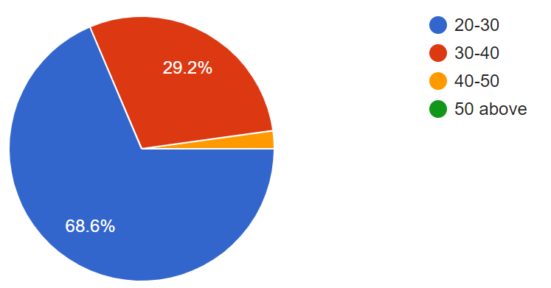
Figure IV-1
The profession like Doctors normally belong to the younger group especially when it comes to the people who were directly handling the CovID patients and isolation wards there were mostly young doctors but because of the statistical point of view we categorized ages into different groups so according to the survey conduction on 137 people from different cities Figure IV-1 represents the classification of the age group that the people belong to.
Gender

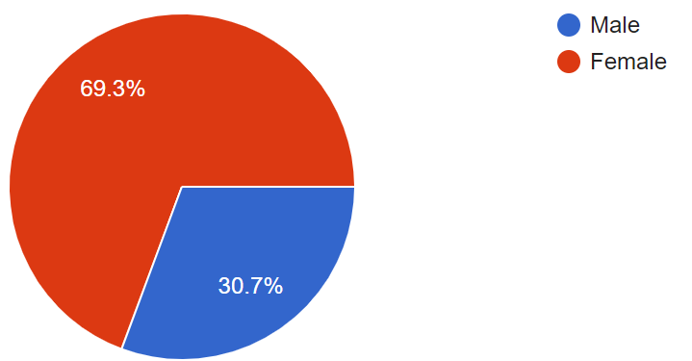
Figure IV-2
The distribution of gender is illustrated in Figure IV-2 that were the part of research.
Marital Status
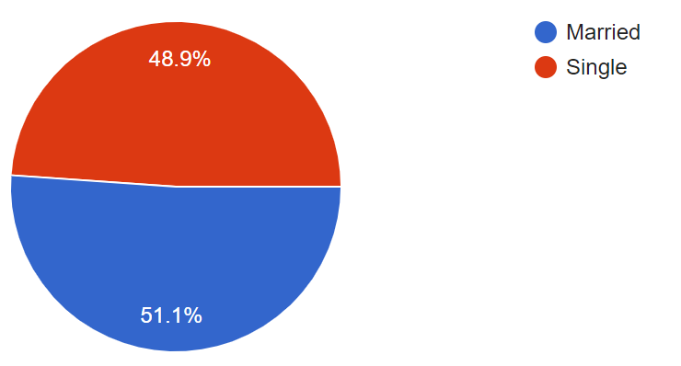
Figure IV-3
Since a married doctor after working on isolation wards have also been interacting with the family and thus it is an important thing to ask about the marital status of the person, so the Figure IV-3 represents the classification of the Marital status of the people.
Education
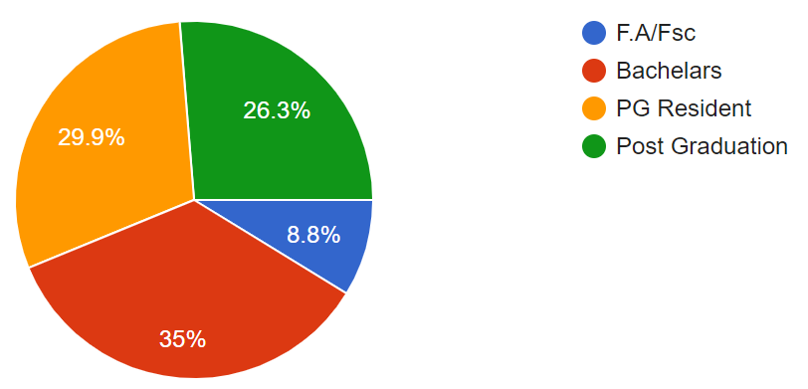
Figure IV-4
The paramedics consist of people from different educational groups and according to the survey conduction on 137 people of different Educational backgrounds Figure IV-4 represents the classification of the education groups division of those people in which they belong to.
Staff Type
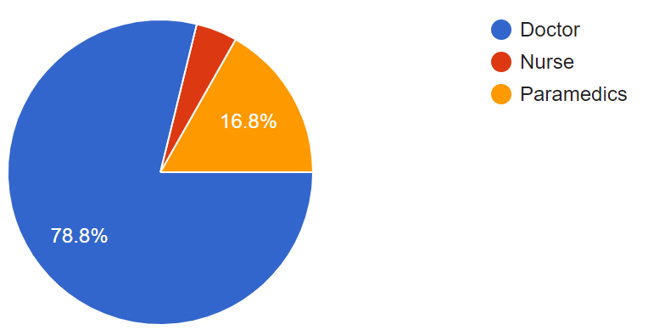
Figure IV-5
As the survey was only conducted on the people belonging to the paramedics’ staff and as we know that the paramedics consist of different groups and so Figure IV-5 represents the staff type of the people who give their reviews in the survey.
Current working department
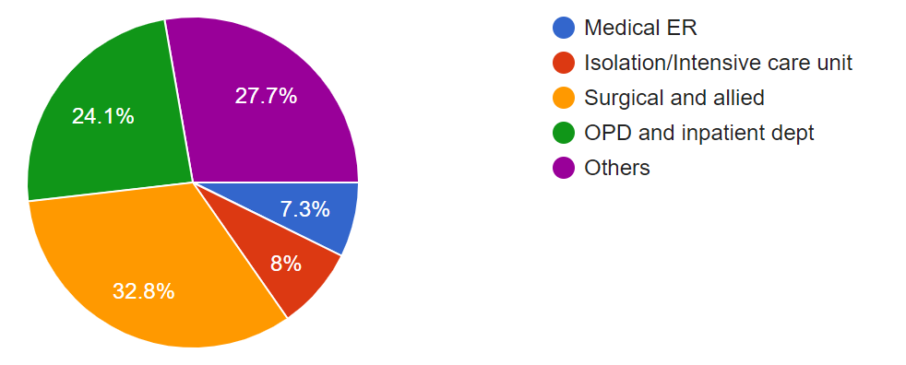
Figure IV-6
The paramedics staff of a hospital works on different situation and so Figure IV-6 represents the classification of working department of paramedics.
Living situation
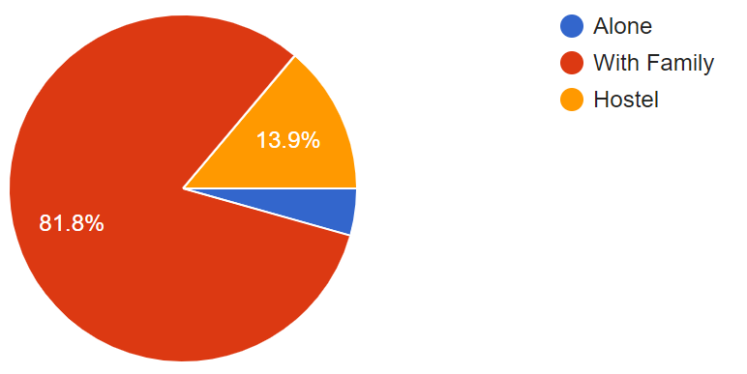
Figure IV-7
The living situation was also a main point in calculation of mental stress of a person and so it is represented in the Figure IV-7.

The columns are analyzed thoroughly, the data type mostly being categorical and ordinal since it was a questionnaire where we must already define the options so that the user can easily fill them out. Once the columns are renamed, we can perform the scoring mentioned by DASS21 paper. That is to add all the scores of the questions belonging to the same category and multiply them by 2. By multiplying the sum of all the columns with 2 we get the scores to a standard so that the responses can be classified into their severity. They could belong to any of the following categories (Normal, Mild, Moderate, Severe, Extremely Severe) depending on the scoring.
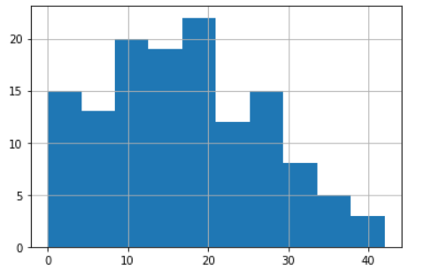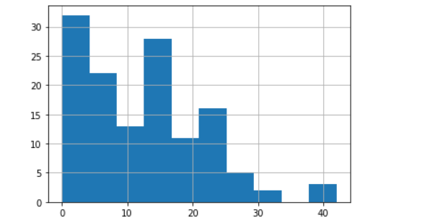
Figure IV-8 Figure IV-9

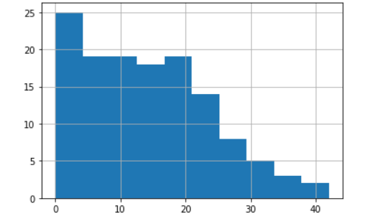
Figure IV-10
Now that we have summarized the data collected by questionnaire and transformed all the questions into three attributes. These attributes are scores of anxiety, stress, and depression, calculated on the bases of responses submitted by health care workers and compiled by using the DASS scoring mechanism. Now the data is analyzed to be approximately uniformly distributed. This was decided by unpleasing the histograms of the scores. Looking at the Figure IV-8, IV-9, IV-10 we can clearly see the distribution, but the histograms were a little misleading, so we analyzed the box plot graph, but in the end, we concluded that the distribution is uniform because the mean and median of the attributes are nearly equal. For stress we have the following values (mean = 17.62, STD = 9.709, median=16.0), for anxiety we get the following values (mean = 12.63, STD = 9.06, median =12.0) Sand for depression we get the following values (mean= 14.43, STD = 9.39, median=14.0).

Once the data was thoroughly analyzed it was concluded that the data distribution represented was nearly normal, and further tests were designed accordingly. Since the population mean and population standard deviation were not known. It was best to estimate the mean parameter by using confidence interval. The confidence interval estimates a range of the population by finding the T-scores using sample data. The confidence interval calculated based on two different significance values. The two significant values being alpha=0.05 and alpha= 0.1.

The scores were calculated in the end and it was found out to which category the score belonged. The categories and scoring system are standard that comes with DASS 21 guidelines. The confidence intervals were found on the complete dataset to estimate the mental conditions of health care workers in the entire country. Then later the confidence interval was calculated for different categories such as cities, genders, education levels, age, living conditions, marital status, department, rank(staff) etc. These confidence intervals give us a general idea about the mental state of the health care workers in Pakistan. The values obtained for anxiety, stress, and depression among all the different categories were compared pairwise using the two-t test and results were recorded. Since the data is assumed to be normally distributed, we are left with limited number of tests to perform on our dataset.

The necessary step that the research followed right from the beginning till the end of the research can be easily represented by the Figure IV-11.

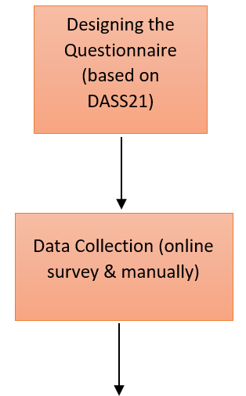
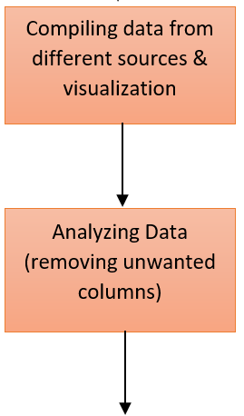
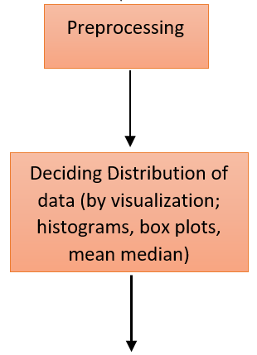
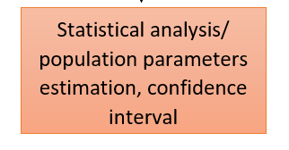
Figure IV-11

Results & Conclusions
The impact of COVID-19 on the region of Pakistan shown in Table V-1 explain what type of situation the south Asian region have faced during the pandemic.
Location | Cases | Recovered | Deaths
Sindh | 244K | 223K | 3,969
Punjab | 156K | 142K | 4,681
Khyber Pakhtunkhwa | 66,451 | 61,656 | 1,879
Islamabad Capital Territory | 41,176 | 39,196 | 476
Balochistan | 18,798 | 18,363 | 194
Table V-4
The gathered data was very diverse in nature. There are 68% female participants and 32% male. If the age brackets are discussed the age grouped (20-30-year-old) was the highest with 70.45%, followed by the age group (30-40 years) with 24.24%. The data distribution with 36.36%,30.3%, 24.2%, 9.09% for Bachelors, PG Residents, Post Grad doctors and intermediate, in education levels, respectively. The 49.2% of the people that responded to the survey were married and 50.8% are single.
Mental Disorder | Alpha | significance level | Lower Level | Upper Level
Depression | 0.05 | 5% | 12.82281 | 16.0559
Anxiety | 0.05 | 5% | 11.0751 | 14.1976
Stress | 0.05 | 5% | 15.3889 | 18.7322
Table V-5
The values fall between different ranges that are categorized by the DASS21 paper. After the overall analysis of the evaluation for mental disorders the depression was found between severe and extremely severe. The anxiety was categorized to be extremely severe. The stress can be categorized into either extremely severe or severe by looking at the calculation with 5% significance shown in Table V-2.
Mental Disorder | Gender | Alpha | significance level | Lower Level | Upper Level
Stress | Male | 0.05 | 5% | 12.3685 | 19.4409
Anxiety | Male | 0.05 | 5% | 8.5213 | 15.0024
Depression | Male | 0.05 | 5% | 10.9590 | 16.6578
Stress | Female | 0.05 | 5% | 15.7444 | 19.4555
Anxiety | Female | 0.05 | 5% | 11.2837 | 14.8051
Depression | Female | 0.05 | 5% | 12.7199 | 16.6578
Table V-6
If the data is segregated between genders. The female participants of the survey scored more in all three categories: stress, anxiety, and depression. For men, the depression is categorized in moderate, severe, and extremely severe brackets. The anxiety for men is either in severe or extremely severe and stress in men is between the moderate, severe, and extremely severe categories. Whereas, for female participants the stress and depression lie in the upper severe and extremely severe category. For anxiety all the female participants fall in the extremely severe category. All this was observed for 5% significance value shown in Table V-3.
Mental Disorder | Marital Status | Alpha | Confidence Level | Lower Level | Upper Level
Stress | Single | 0.05 | 5% | 15.2199 | 19.8248
Anxiety | Single | 0.05 | 5% | 11.0307 | 15.2976
Depression | Single | 0.05 | 5% | 13.7393 | 18.3203
Stress | Married | 0.05 | 5% | 14.0994 | 19.0697
Anxiety | Married | 0.05 | 5% | 9.75725 | 14.4273
Depression | Married | 0.05 | 5% | 10.5276 | 15.0723
Table V-7
When looked at the data with respect to marital status of the participants showed the same. The stress anxiety and depression all fall in two categories its either severe or extremely severe Table V-4.

Mental Disorder | CITY | Alpha | significance level | Lower Level | Upper Level
Stress | Lahore | 0.05 | 5% | 7.3325 | 21.8103
Anxiety | Lahore | 0.05 | 5% | 5.6281 | 17.5147
Depression | Lahore | 0.05 | 5% | 5.4987 | 15.6440
Stress | Islamabad & Rawalpindi | 0.05 | 5% | 16.7224 | 21.5442
Anxiety | Islamabad & Rawalpindi | 0.05 | 5% | 11.1545 | 15.9121
Depression | Islamabad & Rawalpindi | 0.05 | 5% | 11.1545 | 18.1805
Stress | Multan | 0.05 | 5% | 12.2317 | 19.4555
Anxiety | Multan | 0.05 | 5% | 9.2001 | 14.1332
Depression | Multan | 0.05 | 5% | 11.8113 | 15.9664
Table V-8
After observing data on city level, it is found that in Lahore there are some health care workers that might be only mildly stressed, but people both in Islamabad and Multan suffered from extreme disturbance regarding mental health. TableV-4.

Reference
[1] K. K. Wu, S. K. Chan, and T. M. Ma, “Posttraumatic stress after SARS,” Emerg. Infect. Dis., vol. 11, no. 8, pp. 1297–1300, 2005.
[2] J. Lai et al., “Factors Associated With Mental Health Outcomes Among Health Care Workers Exposed to Coronavirus Disease 2019,” JAMA Netw. open, vol. 3, no. 3, p. e203976, Mar. 2020.
[3] R. Rossi et al., “Mental Health Outcomes Among Frontline and Second-Line Health Care Workers During the Coronavirus Disease 2019 (COVID-19) Pandemic in Italy,” JAMA Netw. Open, vol. 3, no. 5, pp. e2010185–e2010185, May 2020.
[4] S. S. Chatterjee, R. Bhattacharyya, S. Bhattacharyya, S. Gupta, S. Das, and B. B. Banerjee, “Attitude, practice, behavior, and mental health impact of COVID-19 on doctors,” Indian J. Psychiatry, vol. 62, no. 3, pp. 257–265, May 2020.
[5] F. Shahzad et al., “Perceived Threat of COVID-19 Contagion and Frontline Paramedics’ Agonistic Behaviour: Employing a Stressor–Strain–Outcome Perspective,” Int. J. Environ. Res. Public Health, vol. 17, no. 14, p. 5102, Jul. 2020.
[6] H. Cai et al., “Psychological impact and coping strategies of frontline medical staff in Hunan between January and March 2020 during the outbreak of coronavirus disease 2019 (COVID) in Hubei, China,” Med. Sci. Monit., vol. 26, pp. e924171-1, Apr. 2020.
[7] R. Mohindra, R. R, V. Suri, A. Bhalla, and S. M. Singh, “Issues relevant to mental health promotion in frontline health care providers managing quarantined/isolated COVID19 patients,” Asian J. Psychiatr., vol. 51, p. 102084, 2020.
[8] L. Kang et al., “The mental health of medical workers in Wuhan, China dealing with the 2019 novel coronavirus,” The Lancet Psychiatry, vol. 7, no. 3. Elsevier Ltd, p. e14, 01-Mar-2020.
[9] “(PDF) Effect of covid 19 on health care workers.” [Online]. Available: https://www.researchgate.net/publication/343222483_Effect_of_covid_19_on_health_care_workers. [Accessed: 14-Nov-2020].
[10] Y. T. Xiang et al., “Timely mental health care for the 2019 novel coronavirus outbreak is urgently needed,” The Lancet Psychiatry, vol. 7, no. 3. Elsevier Ltd, pp. 228–229, 01-Mar-2020.

